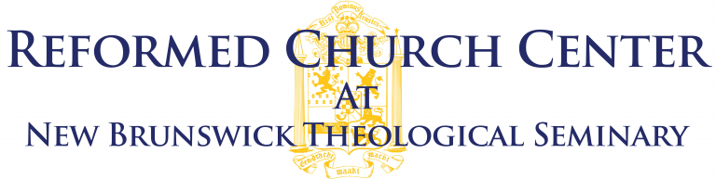

Application/Nomination for Fellows of the Reformed Church Center
Scholars who have made recognized contributions to the study of the RCA and its traditions, but who don’t have institutional academic affiliation, may be appointed by the faculty of New Brunswick Theological Seminary as “Fellows of the Reformed Church Center.” This fellowship does not have a stipend, but can be helpful to scholars for access to research collections and for self-identification in scholarly communication.
The faculty’s Reformed Church Center Committee will recommend scholars for appointment as Fellows. The Center will be sensitive to the gender and ethnic diversity of the Reformed Church in America in making its nominations. Appointments are for a three-year renewable term.
Fellows are expected to be in regular contact with the Center and to make annual reports to the director about the nature and status of their research, which will be then included in the Center’s own reporting of its programs. Fellows are also encouraged to visit the seminary during their terms of appointment.

I am (check one) ☐ applying for a fellowship myself. ☐ nominating a colleague for this fellowship.

If you are nominating a colleague, please fill out below:
Full Name:
 | Last | First | Middle

Phone: |  |  | Email
Your Position:

Relationship to the Nominee:

I ☐ have ☐ have not consulted with the nominee before completing this form.

Applicant/Nominee Information
Full Name:
 | Last | First | Middle

Address:
 | Street Address | Apartment/Unit #

 | City | State | ZIP Code

Phone: |  | Email:

Curriculum Vitae

Copy and paste applicant’s/nominee’s CV here.

Plans for this Fellowship

Complete a short essay here telling the committee about your/the nominee’s current scholarly work (up to 300 words).

References
Please list three professional references.
Full Name: |  | Relationship:
Position: |  | Phone:
Address:
Email:
Full Name: |  | Relationship:
Position: |  | Phone:
Address:
Email:
Full Name: |  | Relationship:
Company: |  | Phone:
Address:
Email:

Disclaimer and Signature
I certify that my answers are true and complete to the best of my knowledge.

Signature: |  | Date:

When this form is complete, please return to jbrumm@nbts.edu.

